3



INDUSTRIAL SURVEYING

3

3

3



4

**Applications**

* Producing 2D drawings or 3D CAD models for refurbishment and restoration projects
* Internal building surveys for floor plans
* 3D urban modeling for planning studies
* Detailed architectural scanning for preservation
* Construction QA and dispute resolution
* BIM (Building Information Models)

**Benefits**

* Faster, safer, less costly, more accurate, and more complete building surveys
* Minimizes impact on use and operation of the building during survey
* Point clouds combined with full-color imagery provide powerful, accurate visualization
* Better 3D city visualization, planning and analysis
* Leverage AutoCAD and Micro Station CAD tools

Heritage & Monuments

Architecture Building

**Applications**

* Detailed recording and preserving of ancient buildings
* Monuments, archeological sites and items of cultural heritage
* Production of drawing to aid restoration and reproduction work
* 3D data collection for movies and walkthroughs for virtual tourism applications within websites and DVD’s

**Benefits**

* Faster, safer, less costly, more accurate, and more complete surveys of complex heritage sites
* Non-contact, remote survey reduces potential damage to sites and improves survey safety
* Reduces sites visits needed for data capture
* Full-color camera options add extra level of information to point clouds for richer analysis

ARCHITECTURE & BUILDING

**Building & Heritage**

* As – built 3D models
* As – built 2D drawings
* Full color visualization

**Industrial**

* Intelligent 3D CAD as – builts
* Retrofit application in plants refineries
* Construction planning

**Civil & Survey**

* Topographic road, rail surveys
* Volumetric calculations in pits, dams, e.t.c.
* Tunnel surveys

**Shipyards**

* Dry dock for yachts
* Hull scanning
* Ship interior scanning
* Accurate marking of water lines
* Shaft alignment & vibration analysis
* Thermographic surveys

HERITAGE & MONUMENTS

APPLICATION AREAS

Surveying Precision

LASER SCANNING & BIM





3

High Pressure Natural Gas and Regulating Station, Tema, Ghana

3

3

INDUSTRIAL SURVEYING

INDUSTRIAL SURVEYING

3

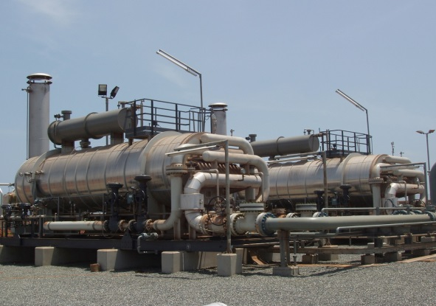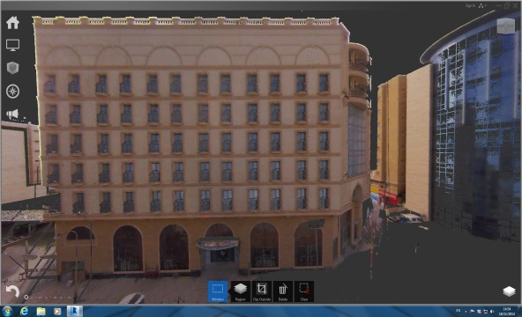

3

**Over 40 construction projects**

* Personnel & equipment provision
* Method statement provision
* General setting out plan creation
* Network installation & maintenance
* Quantity surveys – Cost control
* Determination and control on building’s elements
* Geometry verification and as build surveys.
* ISO standards incorporation – quality control records
* High accuracy applications in corporation

**High accuracy & Industrial Applications**

* Control of axes : alignment, parallelism, verticality, flatness
* Position alignment on large engines or assembly of different parts (flanges, anchors, e.t.c.)

**Laser Scanning and Monitoring Applications**

* Real time AMS deformation monitoring
* Geometry control and verification on prefabricated parts of large constructions in projects like bridges, pipes, wind power generators
* Survey and geometry determination through point cloud collection.
* Deformation analysis

EXPERIENCE

LASER SCANNING

* It is based on exceptionally dense mapping of three- dimensional coordinates of the points on the surface to be surveyed, taken at speeds ranging from a few thousand up to a million points per second.
* Depending on the object (size, shape, desired accuracy), laser scanning may be airborne or terrestrial, static or mobile, autonomous or in combination with other standard topographic methods.
* With the scanner devices, known as LIDAR (Laser Induced Differential Absorption Radar), recording of millions of points is succeeded by creating a cloud, where every point has xyz coordinates in space.
* Laser Scanning is a rapid and reliable surveying method, which provides more accurate products than every other methodology. The big point density in combination with the ability of color information at each point approaches the term of “virtual reality”.

LASER SCANNING & BIM

Civil & Survey Laser Scanning

Industrial Laser Scanning

Building Laser Scanning

Shipyards Laser Scanning

Laser Scanning

www.aksm.gr

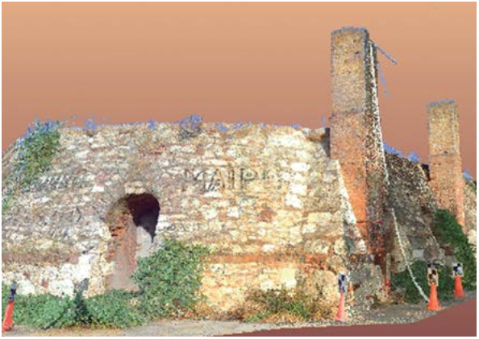

3

‘Alexandros Karditsas & partners

Surveying Consulting Servises’│AKSM│

392 Mesogeion Avenue│15341 Agia Paraskevi, Athens│GREECE

T: +30 210 9702510│F: +30 213 0285617│M: +30 694 4774491

info@aksm.gr

www.aksm.gr

Industrial

Surveying

**SURVEYING PRECISION**

INDUSTRIAL SURVEYING

INDUSTRIAL SURVEYING

Surveying Precision

www.aksm.gr

INDUSTRIAL SURVEYING

Industrial Surveying

**EXPERIENCE**

* **Over 40 industrial projects**
  + Personnel & equipment provision
  + Method statement provision
  + General setting out plan creation
  + Network installation & maintenance
  + Quantity surveys – Cost control
  + Determination and control on building’s elements
  + Geometry verification and as build surveys.
  + ISO standards incorporation – quality control records
  + High accuracy applications in corporation
* **High accuracy & Industrial Applications**
  + Control of axes : alignment, parallelism, verticality, flatness
  + Position alignment on large engines or assembly of different parts (flanges, anchors, e.t.c.)
* **Laser Scanning and Monitoring Applications**
  + Real time AMS deformation monitoring
  + Geometry control and verification on prefabricated parts of large constructions in projects like bridges, pipes, wind power generators
  + Survey and geometry determination through point cloud collection.
  + Deformation analysis

**Over 40 construction projects**

• Personnel & equipment provision

• Method statement provision

• General setting out plan creation

• Network installation & maintenance

• Quantity surveys – Cost control

• Determination and control on building’s elements

• Geometry verification and as build surveys.

• ISO standards incorporation – quality control records

**High accuracy & Industrial Applications**

• Control of axes: alignment, parallelism, verticality, flatness

• Position alignment on large engines or assembly of different

parts (flanges, anchors, e.t.c.)

**Laser Scanning and Monitoring Applications**

• Real time deformation monitoring

• Geometry control and verification of prefabricated parts of large constructions in projects like bridges, pipes, wind power generators

• Survey and geometry determination through point cloud

collection.

**BENEFITS**

• Low mobilization time

• Surveying cost reduction

• Scheduling issues are avoided

• Special equipment is provided

**BENEFITS**

Natural Gas Unit ,Nea Mesimvria Thessaloniki.

* Low mobilization time
* Surveying cost reduction
* Scheduling issues are avoided
* Special equipment provision

Tsakona Bridge, Kalamata

Natural Gas Unit, Nea Mesimvria Thessaloniki

3

2

INDUSTRIAL SURVEYING

Surveying Precision

INTUSTRIAL SURVEYING

www.aksm.gr

**COMPANY’ S PROJECTS**

* Emek S.A. – Halivourgiki SA – RM2 UNIT & SPOOLER UNIT IN HALIVOURGIKI PLANT

Extension of RM2 Unit and Construction of Spooler Unit in Halivourgiki Plant, Eleysina

Civil engineering in earthworks, foundations, underground networks, and substations of the No 2 grid building, rolling warehouse, new RM2 mill, new Spooler building and expansion of RM2 mill

* Emek S.A. – GAS COMPRESSION STATION

Erection of Gas Compression Station in New Messimvria, Thessaloniki.

* J/V Terna S.A., Salini Impregilo S.p.A. – SNFCC

Construction of Cultural Center – Stavros Niarxos Foundation, Athens

* EMEK S.A. – TSAKONA BRIDGE

Construction of Tsakona Bridge - Kalamata

* Intrakat S.A. – 5 NEW SILOS AT HALYPS CEMENT INDUSTRY

Construction of 5 new Silos in the area of Halyps Cement Industry in Aspropyrgos, Attiki

* Terna S.A. – UNIT V MEGALOPOLIS

Construction survey into the construction of Unit V – PPC Megalopolis

* Power Alstom Italia S.p.A. – UNIT III MEGALOPOLIS

Construction of WFGD Unit III at Megalopolis Site

* Emek S.A. – WIND TURBIN TOWERS

Manufacturing of Wind Turbine Towers at Emek S.A. Factory in Aspropyrgos, Attiki

* Emek S.A. – RIO – ANTIRIO BRIDGE

Replacement of Rio – Antirio Bridge special parts

Wind Turbine Towers at EMEK S.A Factory , Aspropyrgos.